UNITED STATES

SECURITIES AND EXCHANGE COMMISSION

Washington, D.C. 20549

FORM 8-K

CURRENT REPORT

Pursuant to Section 13 or 15(d) of the Securities Exchange Act of 1934

Date of report (date of earliest event reported): May 22, 2026

iPower Inc.

(Exact name of registrant as specified in its charter)

Nevada | 001-40391 |  |  |  |  | 82-5144171
(State or other jurisdiction |  |  | (Commission File Number) |  |  | (IRS Employer
of incorporation) |  |  |  |  |  | Identification No.)
 |  |  | 8798 9th Street
 |  |  | Rancho Cucamonga, CA 91730
 |  | (Address of Principal Executive Offices) (Zip Code)
 | (626) 863-7344
 |  | (Registrant’s Telephone Number, Including Area Code)
 | ___________________________
 | (Former name or former address, if changed since last report.)

Check the appropriate box below if the Form 8-K filing is intended to simultaneously satisfy the filing obligation of the registrant under any of the following provisions:

- Written communications pursuant to Rule 425 under the Securities Act (17 CFR 230.425)

- Soliciting material pursuant to Rule 14a-12 under the Exchange Act (17 CFR 240.14a-12)

- Pre-commencement communications pursuant to Rule 14d-2(b) under the Exchange Act (17 CFR 240.14d-2(b))

- Pre-commencement communications pursuant to Rule 13e-4(c) under the Exchange Act (17 CFR 240.13e-4(c)) Securities registered pursuant to Section 12(b) of the Act:

Title of each class |  | Trading Symbol(s) |  | Name of each exchange on which registered
Common Stock $0.001 per share |  | IPW |  | The Nasdaq Stock Market LLC

Indicate by check mark whether the registrant is an emerging growth company as defined in Rule 405 of the Securities Act of 1933 (§230.405 of this chapter) or Rule 12b-2 of the Securities Exchange Act of 1934 (§240.12b-2 of this chapter).

Emerging growth company ☒

If an emerging growth company, indicate by check mark if the registrant has elected not to use the extended transition period for complying with any new or revised financial accounting standards provided pursuant to Section 13(a) of the Exchange Act. ☐

Item 3.03 Material Modification to Rights of Security Holders.

To the extent required by Item 3.03 of Form 8-K, the information regarding the Reverse Stock Split (as defined below) contained in Item 5.03 of this Current Report on Form 8-K is incorporated by reference herein.

Item 5.03 Amendment to Articles of Incorporation or Bylaws

On December 21, 2025, the stockholders of iPower Inc. (the “Company”) holding a majority of the voting power of the Company’s common stock approved via written consent the execution of one of more reverse stock splits of the Company’s common stock, par value $0.001 per share (the “Common Stock”) at a ratio of up to one-for-two hundred and fifty (1:250), with the exact ratio and timing to be determined by the Board of Directors of the Company (the “Board”) in its discretion. This approval was reported on a Schedule DEF14C filed with the Securities and Exchange Commission on January 21, 2026, which became effective on February 10, 2026.

Pursuant to such authority granted by the Company’s stockholders, on May 4, 2026, the Board approved a reverse split of one-for-eight (1:8) (the “Reverse Stock Split”) of the Common Stock. On May 20, 2026, the Company filed a certificate of amendment to amend the Sixth Amended and Restated Articles of Incorporation of the Company (the “Certificate of Amendment”) with the Secretary of State of the State of Nevada, with an effective date of May 22, 2026 (the “Effective Date”). The Reverse Stock Split will become effective at the start of trading on May 22, 2026 (the “Effective Time”).

When the Reverse Stock Split becomes effective, every eight (8) shares of the Company’s issued and outstanding Common Stock immediately prior to the Effective Time shall automatically be reclassified into one (1) share of Common Stock, without any change in the par value per share. The Reverse Stock Split reduces the number of shares of Common Stock issuable upon the exercise or vesting of the Company’s outstanding stock options and warrants in proportion to the ratio of the Reverse Stock Split and causes a proportionate increase in the exercise prices of such stock options and warrants. Restricted stock units will be adjusted to reflect the reduced number of underlying shares. The Reverse Stock Split did not change the Company’s total number of authorized shares of Common Stock or preferred stock.

No fractional shares will be issued as a result of the Reverse Stock Split. Stockholders who otherwise would be entitled to receive a fractional share in connection with the Reverse Stock Split will receive one full share of the post-Reverse Stock Split Common Stock in lieu of such fractional share.

VStock Transfer LLC is acting as exchange agent for the Reverse Stock Split and will notify stockholders of record regarding the Reverse Stock Split. Stockholders who hold their shares in book-entry form or in “street name” (through a broker, bank or other holder of record) are not required to take any action.

Commencing on May 22, 2026, trading of the Company’s Common Stock will continue on The Nasdaq Capital Market on a Reverse Stock Split-adjusted basis. The new CUSIP number for the Company’s Common Stock following the Reverse Stock Split is 46265P305.

The foregoing description of the Certificate of Amendment does not purport to be complete and is qualified in its entirety by reference to the full text of the Certificate of Amendment, which is filed as Exhibit 3.1 to this report and incorporated by reference herein.

2

Item 7.01 Regulation FD Disclosure.

On May 19, 2026, the Company issued a press release announcing the Reverse Stock Split. A copy of the press release is attached hereto as Exhibit 99.1 and is incorporated herein by reference.

In accordance with General Instruction B.2 of Form 8-K, the information in this Item 7.01 of this Current Report, including Exhibit 99.1, shall not be deemed “filed” for the purposes of Section 18 of the Securities Exchange Act of 1934, as amended (the “Exchange Act”), or otherwise subject to the liabilities of that section, nor shall it be deemed incorporated by reference in any filing under the Exchange Act or the Securities Act of 1933, as amended, except as shall be expressly set forth by reference in such a filing. Furthermore, the furnishing of information under Item 7.01 of this Current Report is not intended to constitute a determination by the Company that the information contained herein, including the exhibits hereto, is material or that the dissemination of such information is required by Regulation FD.

Item 9.01 Financial Statements and Exhibits.

(d) Exhibits
Exhibit No. |  |  | Description
3.1 |  | Certificate of Amendment to the Sixth Amended and Restated Articles of Incorporation
99.1 |  | Press release of the Company issued on May 19, 2026

- Cover Page Interactive Data File (embedded within the inline XBRL document)

3

SIGNATURES

Pursuant to the requirements of the Securities Exchange Act of 1934, the registrant has duly caused this report to be signed on its behalf by the undersigned hereunto duly authorized.

IPOWER, INC.

Dated: May 22, 2026

By: /s/ Chenlong Tan
Name: Chenlong Tan

Title: Chief Executive Officer

4

Exhibit 3.1
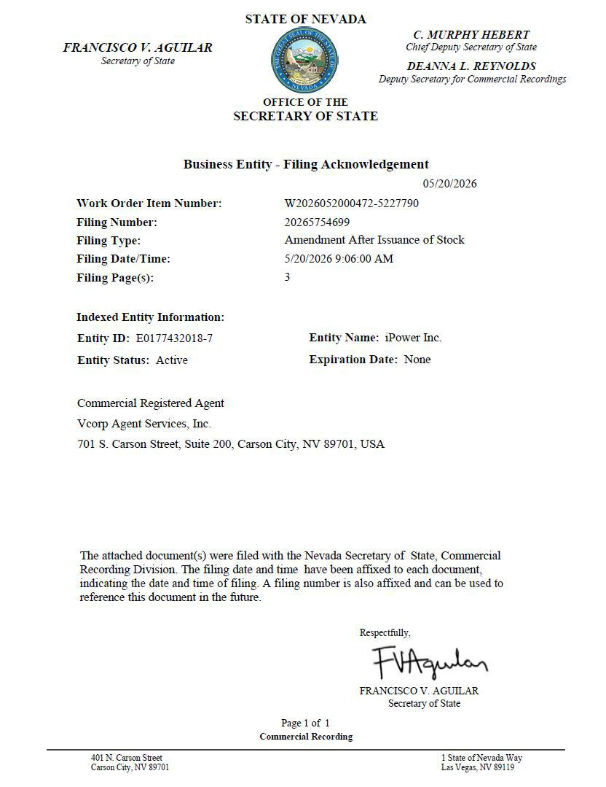

1

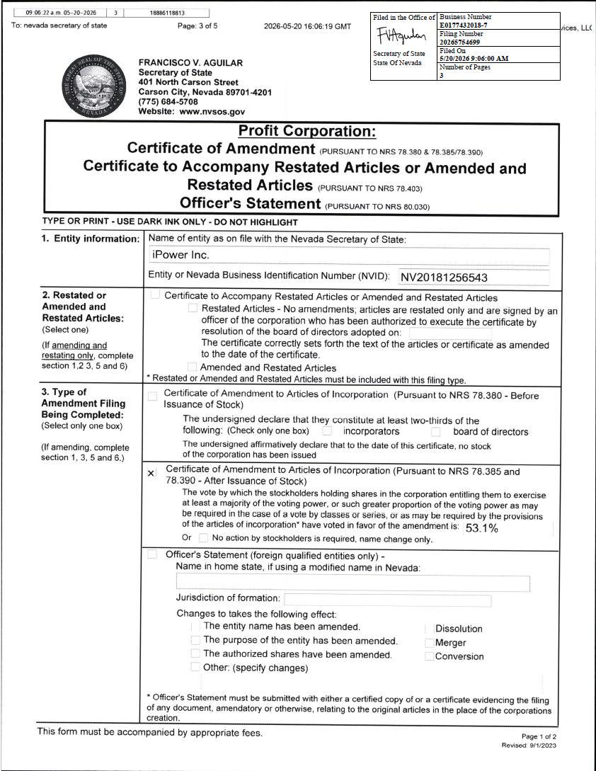

2

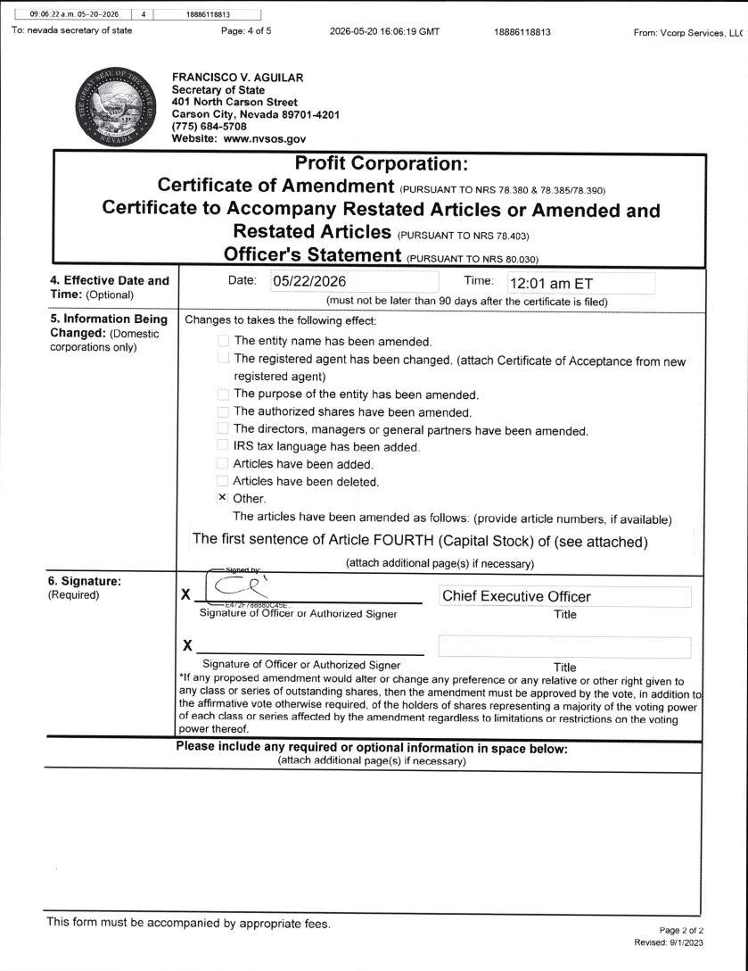

3

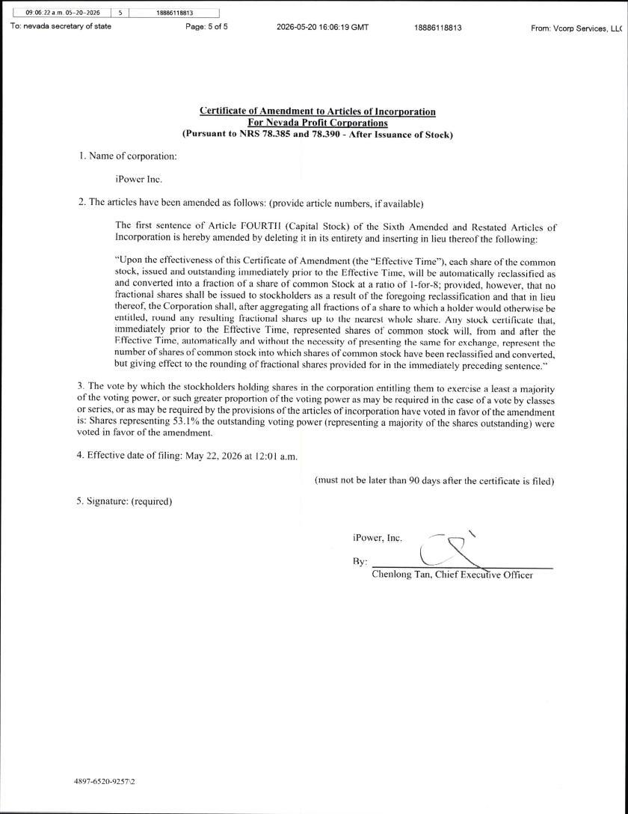

4

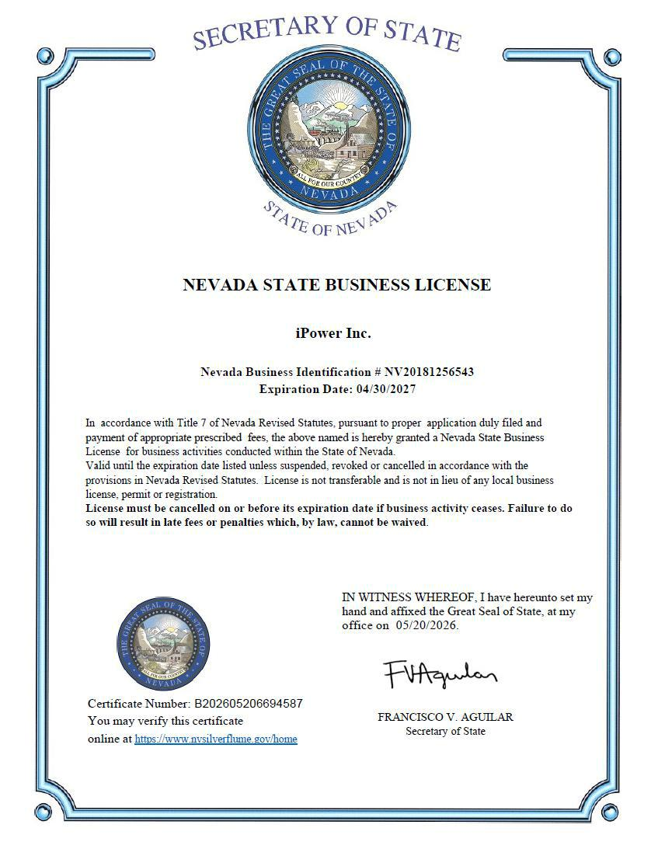

5

Exhibit 99.1


iPower Inc. Announces 1-for-8 Reverse Stock Split

May 19, 2026

RANCHO CUCAMONGA, Calif., May 19, 2026 (GLOBE NEWSWIRE) -- iPower Inc. (Nasdaq: IPW) (“iPower” or the “Company”), a technology- and data-driven supply chain and infrastructure provider for online retailers and brands, today announced that it will effect a 1-for-8 reverse stock split of its issued and outstanding common stock.

The reverse stock split will become effective at 12:01 a.m. Eastern Time on May 22, 2026, and the Company’s common stock will begin trading on a split-adjusted basis on The Nasdaq Capital Market at the market open on May 22, 2026 under the existing ticker symbol “IPW.”

The new CUSIP number for the Company’s common stock following the reverse stock split will be 46265P305.

As a result of the reverse stock split, every eight shares of the Company’s issued and outstanding common stock will automatically be combined into one issued and outstanding share of common stock. No fractional shares will be issued in connection with the reverse stock split, and stockholders who would otherwise be entitled to receive a fractional share will receive cash in lieu thereof. Prior to the reverse split, there were a total of 5,289,919 shares of common stock outstanding. Following the reverse split, there will be a total of approximately 661,240 shares of common stock outstanding.

The Company is effectuating the reverse stock split to increase the per share trading price of the Company’s common stock to ensure the Company maintains compliance with the minimum bid price requirement for continued listing on The Nasdaq Capital Market.

The reverse stock split was approved by the Company’s board of directors and stockholders.

VStock Transfer, LLC is acting as the exchange agent and transfer agent for the reverse stock split. Registered stockholders holding pre-split shares electronically in book-entry form are not required to take any action to receive post-split shares. Stockholders owning shares through a bank, broker, custodian or other nominee will have their positions automatically adjusted to reflect the reverse stock split, subject to such broker’s particular processes.

About iPower Inc.

iPower Inc. (Nasdaq: IPW) is a technology- and data-driven supply chain and infrastructure provider for online retailers and brands, operating at the intersection of digital assets and real-world commerce. The Company delivers procurement, fulfillment, logistics, and software-enabled services, and is executing a broader crypto strategy through licensed partners and compliant infrastructure. For more information, please visit www.meetipower.com.

Forward-Looking Statements

All statements other than statements of historical fact in this press release are forward-looking statements. Such statements involve known and unknown risks and uncertainties and are based on current expectations and projections. Actual results may differ materially from those set forth herein. iPower undertakes no obligation to update forward-looking statements except as required by law. Investors are encouraged to review iPower’s filings with the Securities and Exchange Commission, including its Annual Report on Form 10-K, Quarterly Reports on Form 10-Q, and Current Reports on Form 8-K.

Media & Investor Contact

IPW.IR@meetipower.com

